Doctor: _______________________________________ Date: _________________________
Patient: _______________________________________ Return Date: ___________________
Dentures
Standard | □
Economy | □
Acrylic Partial
Flipper 1-3 teeth | □
Acrylic 1-6 teeth | □
Support Services
Bite Rim | □
Custom Tray | □
Processed Base | □
Night Guards
Hard Night Guard | □
Hard/Soft Guard | □
Bleaching Tray | □
Repairs
Hard Reline | □
Soft Reline | □
Cast Clasp | □
Replace Tooth | □

Tooth Shade:____ _____
Acrylic Shade:____ ____

Please Indicate Case Specific Instructions:

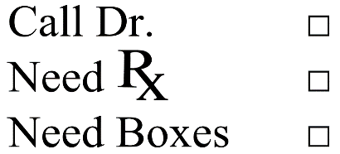
Clinician Signature: ____________________________
License Number: ____________________________

